App My Kind VOICE - what you need to know
The APP developed within the project provides a pathway through 16 digital activities that engage children in a journey on the issues of bullying and cyberbullying. The game activities stimulate reflection and critical thinking and at the same time activate prevention and protection mechanisms with respect to the problem. In fact, different themes are addressed, guiding children to explore different dimensions of relationships, words and related behaviours, trying to distinguish relationships of friendship, care and kindness from relationships of exclusion, violence and (cyber)bullying. The attention to children's relationships, based on respect, recognition of the other and inclusion, is a fundamental form of primary prevention of the phenomenon of bullying and finds an important dimension in this App: we play and reflect on friendship, respect, kind words, and inclusion. Ample space is also given to the recognition of emotions: knowing how to "feel" an emotion, in oneself and in others, is another fundamental life skill that is important for the prevention of violence and bullying, since it is generated from empathy and listening. The App also addresses other issues: rules of media use for example, both at school and in the family, provide important food for thought on how to have a healthy relationship with media and find a common language to talk about it. Other activities help children understand who they can turn to in case of need, to find help or to be supported when they feel something is wrong, so that they are always safe and secure online.

The game takes place in a fantasy world of cute monsters, in which children - moving between the home and school context - have to perform different tests and different games that address the themes described above.
The game kicks off with the creation of an avatar monster, which allows children to enter and become the protagonists of the APP. The creation of the avatar stimulates the creativity and imagination of the participants, as it is built through the assembly of small parts that can be changed in color, size, combination, etc: children are able to obtain dozens of cute combinations that most respond to their imagination. The avatar is completed through the creation of a name and some personal characteristics. The creation of an avatar is important as it allows children to be actively involved in the game, facing situations first-hand but at the same time remaining protected by a fantasy identity.
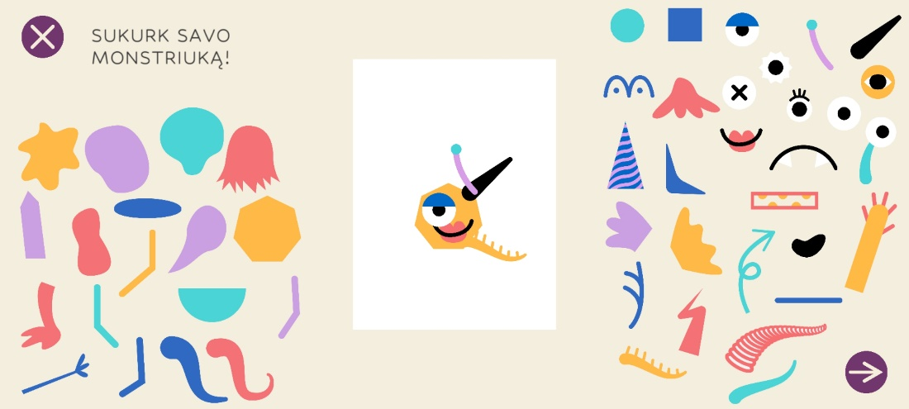
After the avatar is created, children decide whether to play in the "home" or "school" environment depending on how the pathway is structured.
School

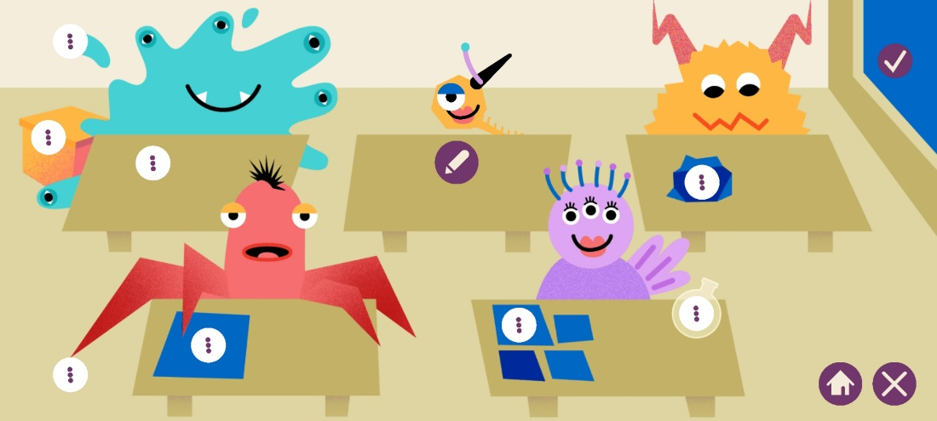
Home
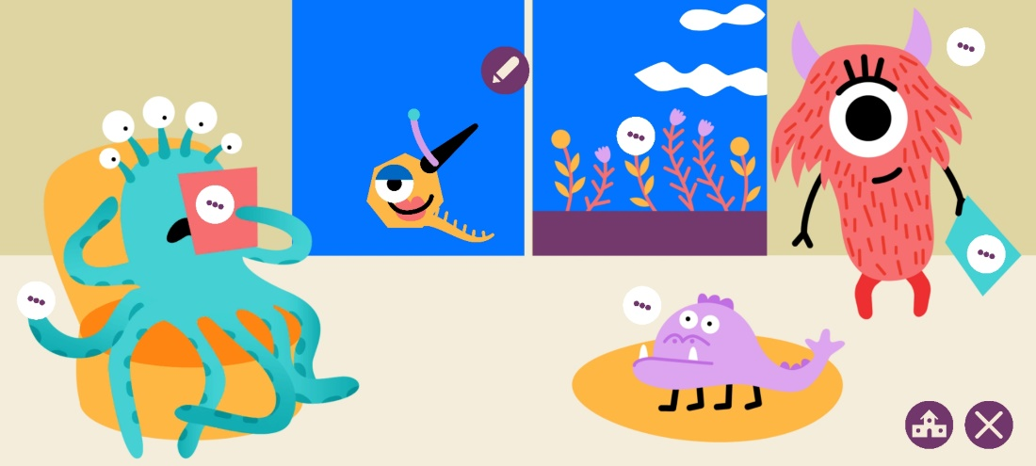
The decision to create two play environments address the need to activate that co-participation in the children's educational journey, which is central to the process of co-education. Even if the activities are autonomous in themselves, the process can be facilitated across home and school in order to create ongoing reflections between teachers and families. For example, teachers can facilitate some activities at school and assign children the task of doing other tasks at home with their families, in order to take up and deepen the concepts addressed; also, the possibility of doing some dedicated activities at home support the parents in working on typical family situations with new tools for dialogue and action.
It is recommended that, at the beginning of the pathway, teachers facilitate a meeting with families to propose the general objectives and a plan of action that highlights which activities will be done at school, and which are proposed to be done at home. A tool for sharing the most important information that emerges during the course, such as a shared digital whiteboard between parents and teachers, could be very useful in this regard, so that there is a unified view of the work being done at home or at school.
The path in the two play environments winds through these activities and themes and are represented in the game by different characters-friendly monsters:
NOTE: Some monsters introduce several activities

School environment:
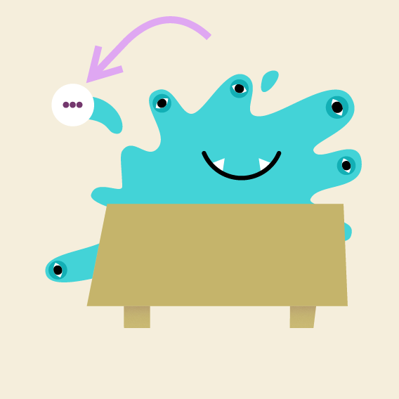 | Buddy or Bully: the activity presents some common situations between children and young people and asks the participant to reflect and decide whether the behaviour is of a buddy or a bully
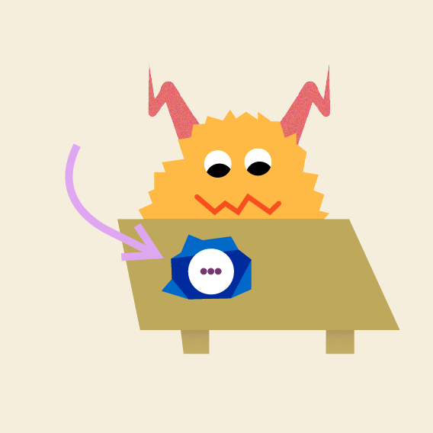 | Coded message: in this case, children have to play with words, decoding an apology and friendship request message and creating a new coded message
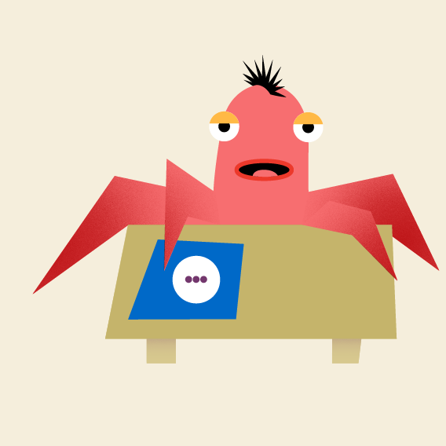 | Fill in the gaps: activity helps children to set some rules for being safe online
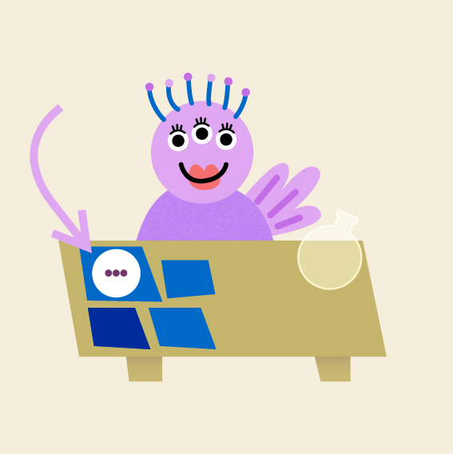 | Recognize the emotions: the game encourages children to recognize the emotions expressed by other children's photos, and to name them
 | Against sadness: the game helps children to decide and discuss what activities they can do when they feel sad to try to express their emotions and feel better
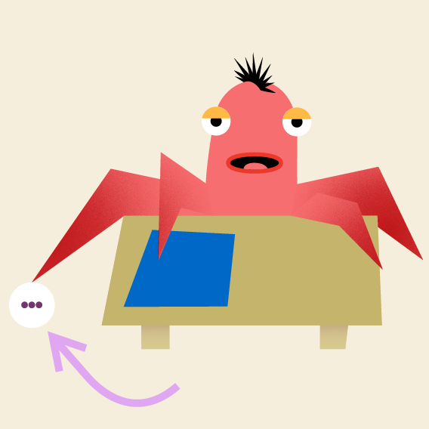 | Wheel of feelings: the game helps children to reflect on the emotions they feel and name them, associating them with significant episodes or moments in their lives
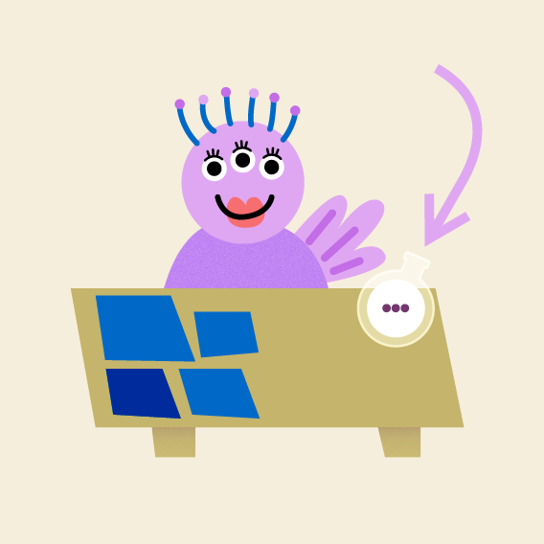 | Science Class, the game guides children to reflect and decide what elements create friendship and empathy
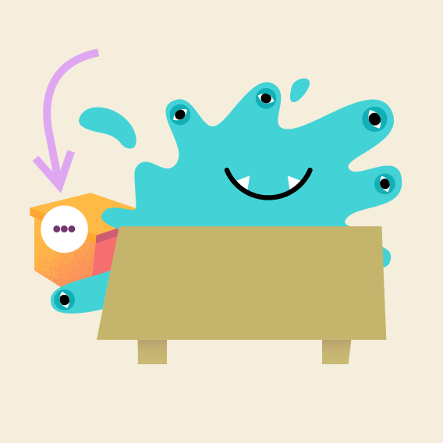 | Memory game, the game supports children to recognize and choose kind and friendly words to compose a birthday gift
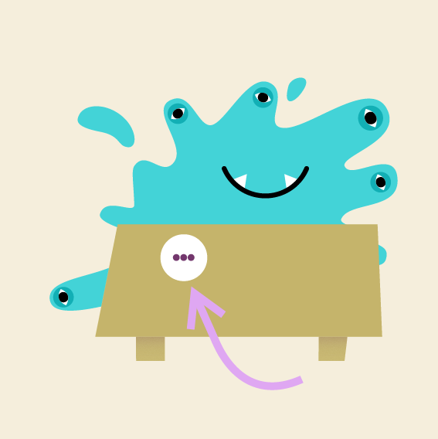 | How does it feel like? the game tries other senses, such as hearing or taste, to "feel" and express emotions of inclusion and exclusion through other sensorial channels
Home:
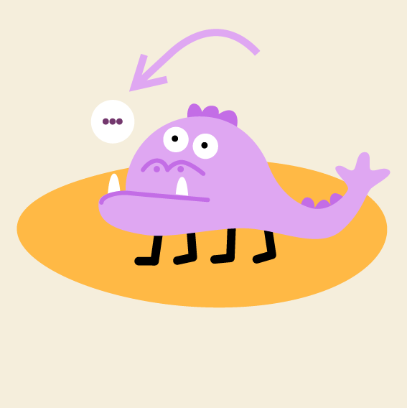 | What makes you comfortable
 | If you ever feel unsafe
It's ok, it's not ok
They investigate the feelings and emotions one child may experience when using social media, what is positive and what is not
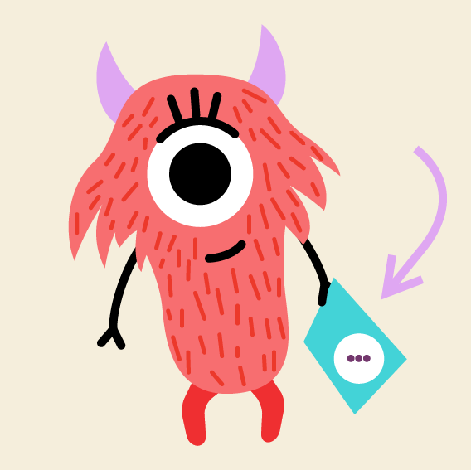 | Family rules, helps the family establish reasoned and shared rules for using social media in a playful and participatory way
 | Emphatic gardener
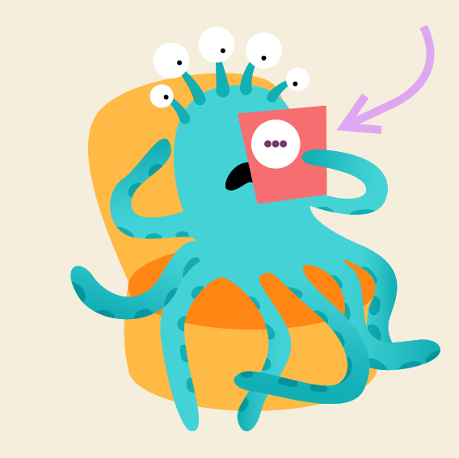 | and The Labyrinth guide children to choose the kind words that make a friendship flourish, and the words that undermine it

The APP, as well as the other digital tools proposed in the project, also includes the possibility of doing analogue activities: each activity in the APP is accompanied by a small workshop activity that picks up on it, expanding or deepening it better. As already explained in the introduction to the toolkit, the use of analogue activities helps children to slow down their thinking, to stimulate the emergence of creative ideas, to give time to better understand what they learned.
Analogue activities are described step by step in the following section.

